Why Baseball is the Greatest Sport

According to a <http://news.gallup.com/poll/224864/football-americans-favorite-sport-watch.aspx> 2018 Gallup poll, baseball (9%) ranks #3 in popularity of American sports, behind football (37%) and basketball (11%) when asked what sport is the favorite to watch. As a lover of America’s true pastime, baseball, I am here to convince you why baseball is the greatest sport and America needs to come to its senses. This article will focus on comparing baseball to the two sports ranked above it, football and basketball. I will address several main arguments and take aim at some of the common gripes regarding the sport that have caused its popularity to decline over the past few decades.

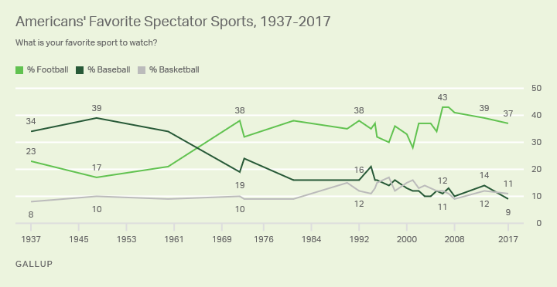

**“It’s too slow”**

The biggest complaint I hear from people about baseball is “it’s too slow” or “it’s sooooo boring.” Baseball is a game unlike most other major sports because there is no game clock. A half-inning could take 1 minute or 20 minutes, and a game could last over 8 hours (May 8, 1984: White Sox vs. Brewers). However, the average game time of a baseball game (~3 hours, 5 minutest) is actually shorter than football (~3 hours, 12 minutes). Now the common response is, “but wait, baseball has a lot of standing around waiting for the pitcher to throw, while football is heart-stopping action!” But hold on a second, according to a Wall Street Journal article <https://www.wsj.com/articles/SB10001424052748704281204575002852055561406> , the average football play lasts only 4 seconds for a total of only 11 minutes of action for the entire game. By comparison, there are approximately 18 minutes of action in a baseball game.

**“You don’t have to be athletic”**

Another thing I hear a lot is that baseball players aren’t very athletic. Look at basketball players, they can dunk; and football players are strong and fast, running around all game. However, baseball is an incredibly athletic sport, requiring fast-twitch movements for plays that only last several seconds and a 5.5-ounce ball that travels over 100 mph out-of-the-hand and off the bat. Have you ever tried going to a batting cage and hitting a ball that travels even 80 mph? How about going out to a baseball diamond and fielding a ground ball hit 80 mph at you? The lateral movement and quickness required to figure out where a 100 mph ball will land, and then catch it is incredibly difficult. Baseball player speeds are on par with athletes in both football and basketball.

**Game for the common people**

There’s a reason why baseball is considered America’s pastime. It’s a game that brings people together and one that anyone can be a professional in. The following chart was put together by SportChart: <https://sportchart.wordpress.com/2014/05/30/athlete-sizes-update/>

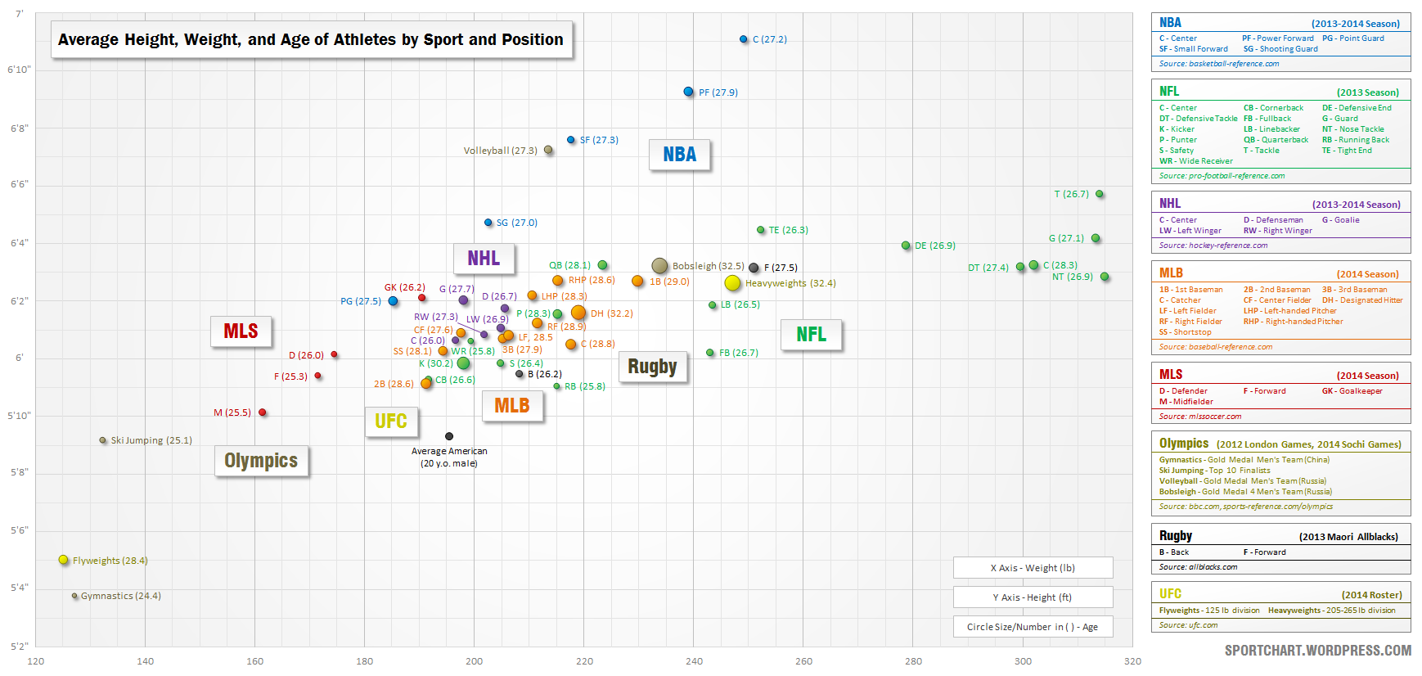

The black dot in the middle shows the average 20-year-old American male. As we can see, the distribution of MLB players is the closest to that of the average male in the United States. Most NFL players are taller and a lot heavier than baseball players, while basketball players are among the highest percentiles in height. A random person who aspires to be a professional athlete can immediately be disqualified in the NBA and NFL simply due to size. Baseball on the other hand does not have as much of a bias toward common folk. Furthermore, the developmental league in the MLB versus the NFL and NBA is much larger, providing more people the opportunity to be a professional athlete. For comparison, the NFL during the season has 32 teams with a 53-man active roster and 10 extras on the practice squad for a total of 2,016 professional football players. The NBA has 30 teams with an average of 14 players per team plus 26 additional G-League teams with a max of 13 players each for a total of 758 professional basketball players. Comparatively, while the NFL and MLB only have one level of “minor league” development, the MLB has an expansive hierarchy of minor league teams, from lowest to highest: Rookie, Low-A, A, Advanced-A, Double-A, Triple-A. The top four levels have a 25-man active roster limit, while the lower two have a 35-man active roster limit. When you add in the 25-man Major League roster for each of the 30 teams, there are a total of roughly 5,850 professional baseball players!

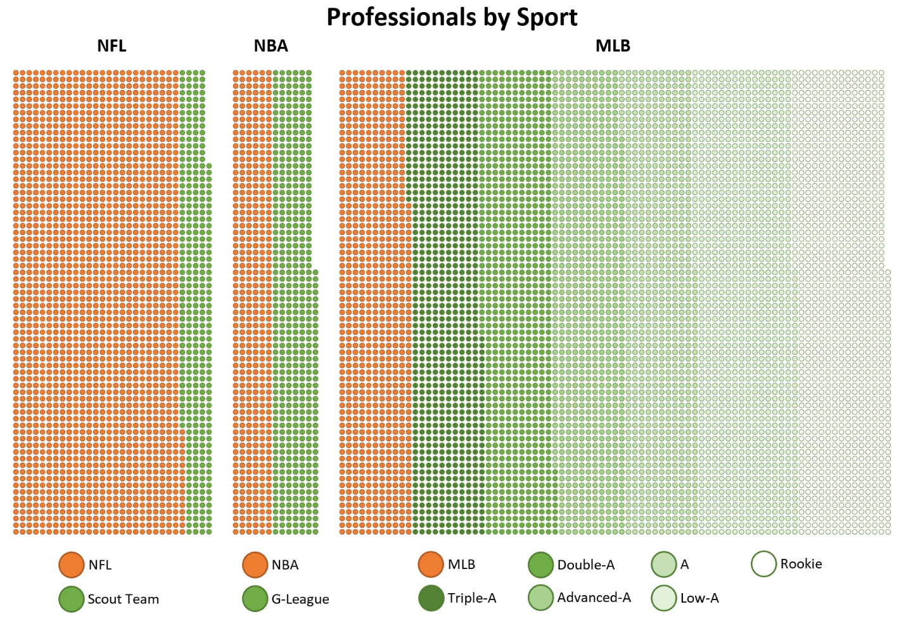

**Ultimate team game**

Finally, although all of these are team sports, baseball is the least reliant on superstars and most based upon a collective team effort. Let’s start with the easiest one, basketball. In the NBA, even one all-star can drastically affect the fortunes of a team. Take LeBron James and the Cleveland Cavaliers, for instance. In the twelve seasons between 2005 and 2017, the Cavaliers won at least one round of the playoffs, including making the finals in four seasons, in every year except 2010-2014 when LeBron was on the Miami Heat. In fact, in those four seasons they didn’t win one round of the playoffs, they didn’t even make the playoffs. Similarly, the Lakers even with Kobe didn’t win another championship from when Shaq left until Pau Gasol joined the team. With only five players on the court at a time, one player can have a significant impact on a game. For example, on November 5, 2017, with points scored and assists James Harden accounted for 91 points or 67% of the Rockets’ points that night.

Now I will not try to argue that football doesn’t require a great deal of teamwork from the offensive line to the linebackers and secondary communication and having three different units. However, like basketball one superstar can have a huge impact on a team. In particular, a quarterback or defensive lineman can transform an offense or defense. A quarterback touches the ball every offensive snap and most teams struggle without a quality quarterback even if the rest of the team is comprised of good players.

Baseball, however, is a game which is uniquely resistant to any individual player having a huge impact on a team. Players in football and basketball that have the biggest impact are those who are involved in the most plays per game. In baseball that would be a starting pitcher. But because of physical limitations, starting pitchers can only pitch every five or six games which limits their overall impact. Even the best pitchers still have bad outings, and whether the team wins their starts also depends on how many runs their offense scores. For instance, in 2010 Felix Hernandez won the AL Cy Young with a 13-12 record, barely above .500. On the other side of the ball, an excellent offensive player only impacts the game with three or four at-bats per game, and only gets a hit every third at-bat. There are many variables that affect his ability even to have an *opportunity* to impact the game: runners on base, getting walked or hit by a pitch, and score of the game. Baseball relies on a combination of defense, the ability to string together hits by multiple players, and multiple pitchers being able to limit an opposing offense.